**How to use QPushButton - An Example**

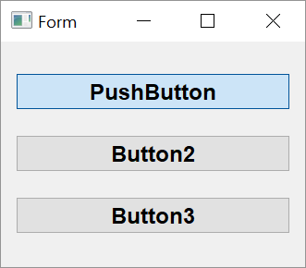

**Step 1**

**Adding the widgets to the form**

1. Drop three instances of Push Button widgets on the form and put them in Vertical layout.
2. Assign object names as b1, b2 and b3.
3. Save the form as btn.ui and generate its Python script using pyuic5 utility.

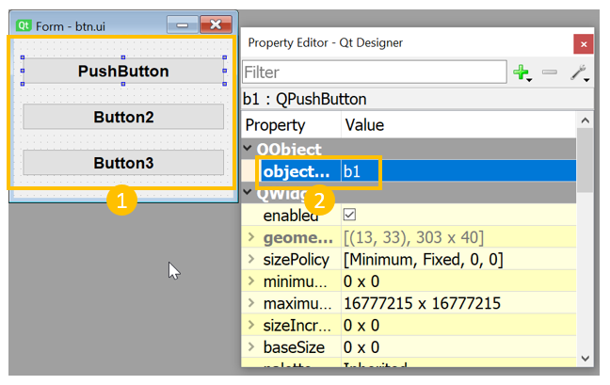

**Step 2**

**Creating a toggle button**

1. For setting btn 1 as a toggle button, add the following lines in setupUi() method:

**self.b1.setCheckable(True)**

**self.b1.toggle()**

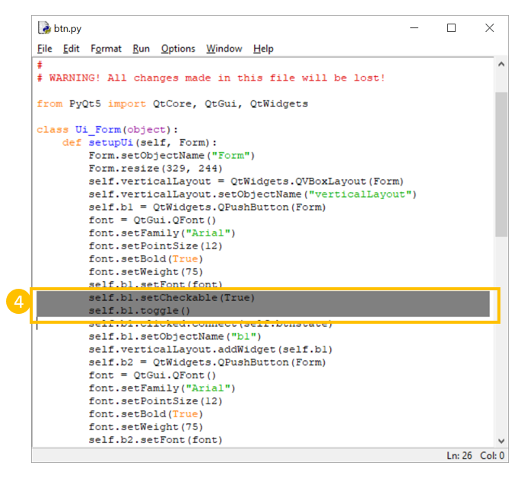

1. For the toggle button, to change the caption of b1 according to its state, add the following method in the Ui-Form class generated by pyuic5 utility

**def btnstate(self):**

**if self.b1.isChecked():**

**self.b1.setText("pressed")**

**else:**

**self.b1.setText("released")**

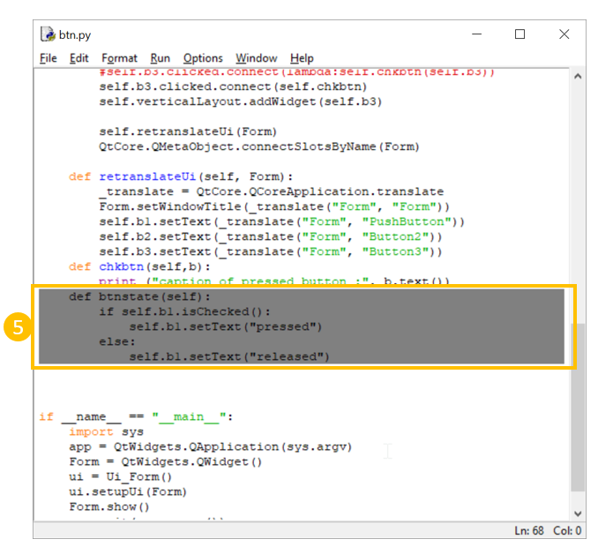

1. Use this method as slot for clicked signal emitted by b1. Add the following statement in the script.

**self.b1.clicked.connect(self.btnstate)**

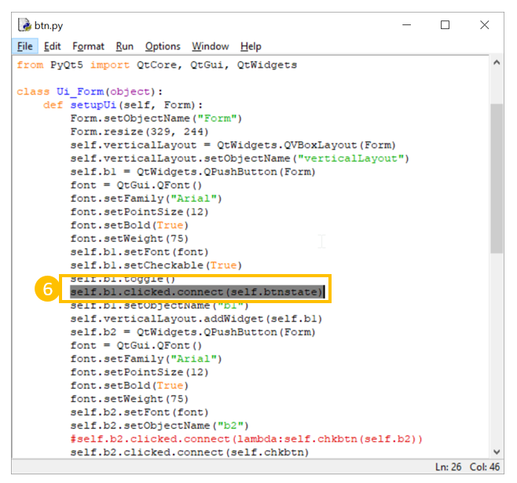

**Step 3**

**Identifying which button has been clicked**

1. We want to identify which button out of b2 and b3 has been clicked. Add following method in the class and connect the same to clicked signal of b2 and b3.

**def chkbtn(self,b):**

**print ("caption of pressed button :", b.text())**

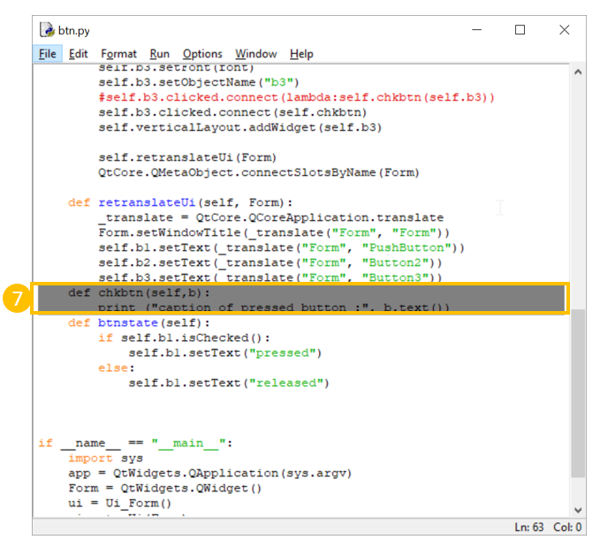

1. Add following lines in setupUi() method

**self.b2.clicked.connect(lambda:self.chkbtn(self.b2))**

**self.b3.clicked.connect(lambda:self.chkbtn(self.b3))**

